CURICULUM VITAE

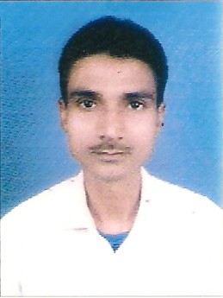

Abhijeet
Village – Rampur, P.O- Jamalpur
Dist- Munger, State- Bihar
Mobile - 8051153448
Email – abhijeet.abhijeet81@gmail.com
Current location –Daltonganj at Palamau, Jharkhand.

Career Objective
An effective, hard working and keen listener looking to acquire a position in legal department where I could use my skills for the profitability of the organization.
Professional synopsis
A qualified LLB with wide interest in Litigation, Legal Affairs & Documentation.
An effective communicator with exceptional relationship management skills and adapt at maintaining cordial business relationship .
Qualification highlights

Exam passed | School/College | Board/University | % of marks | Year of passing
LLB | TNB Law College, Bhagalpur,Bihar | Tilka Manjhi Bhagalpur,Bihar | 59.39 | 2010
HSSE | Subhash Public School,Giridih,Jharkhand | CBSE | 64.00 | 2004
SSE | DAV Public School,Godda, Jharkhand | CBSE | 53.80 | 2002

Certification
-Certification of admission as an Advocate,under the Advocates Act ,1961 from BIHAR STATE BAR COUNCIL,PATNA

Practice

-Enrolled and Practicing as an Advocate in Munger, Civil Court ,Bihar.

IT Skills

-MS-Office.
-Windows 2000/XP/
-Internet Applications and E-Mail.
Assertive nature.
-Strong work ethics.
-Effective communication skills.
-Sound knowledge of the legal terms & policies.
-Good convincing & negotiating skills.
-Hardworking.
Key Skills
-Good command over legal concept.
-Excellent knowledge of laws and legal aspects.
-Keen listening skills.
-Good analytical and reasoning skills.
-Self motivated.
-Good time management skills.

Hobbies
-Playing Cricket.
-Internet surfing.
-Watching movies.

PERSONAL INFORMATION

Father's name Jitendra Prasad Singh
Mother's name Anita Singh
Date of Birth 01-02-1987
Nationality Indian
Religion Hindu
Language Hindi,English
Marital Status Single
Sex Male

ACHIEVEMENTS

- PASSED IBPS CLERK AND PO COMMON WRITTEN EXAM.[1st PHASE]
- PASSED IBPS RRB PHASE 3 WRITTEN EXAM.
- PASSED C.I.S.F H.C MINISTRIAL WRITTEN EXAM.
- SELECTED AS LIC DIRECT SALES EXECUTIVE.

DECLARATION
I Abhijeet hereby declare that all the above information is true to best of my knowledge.

ABHIJEET

